THE PROFESSIONAL SERVICES AND FACILITIES OF OUDE WESTHOF CARE CENTRE
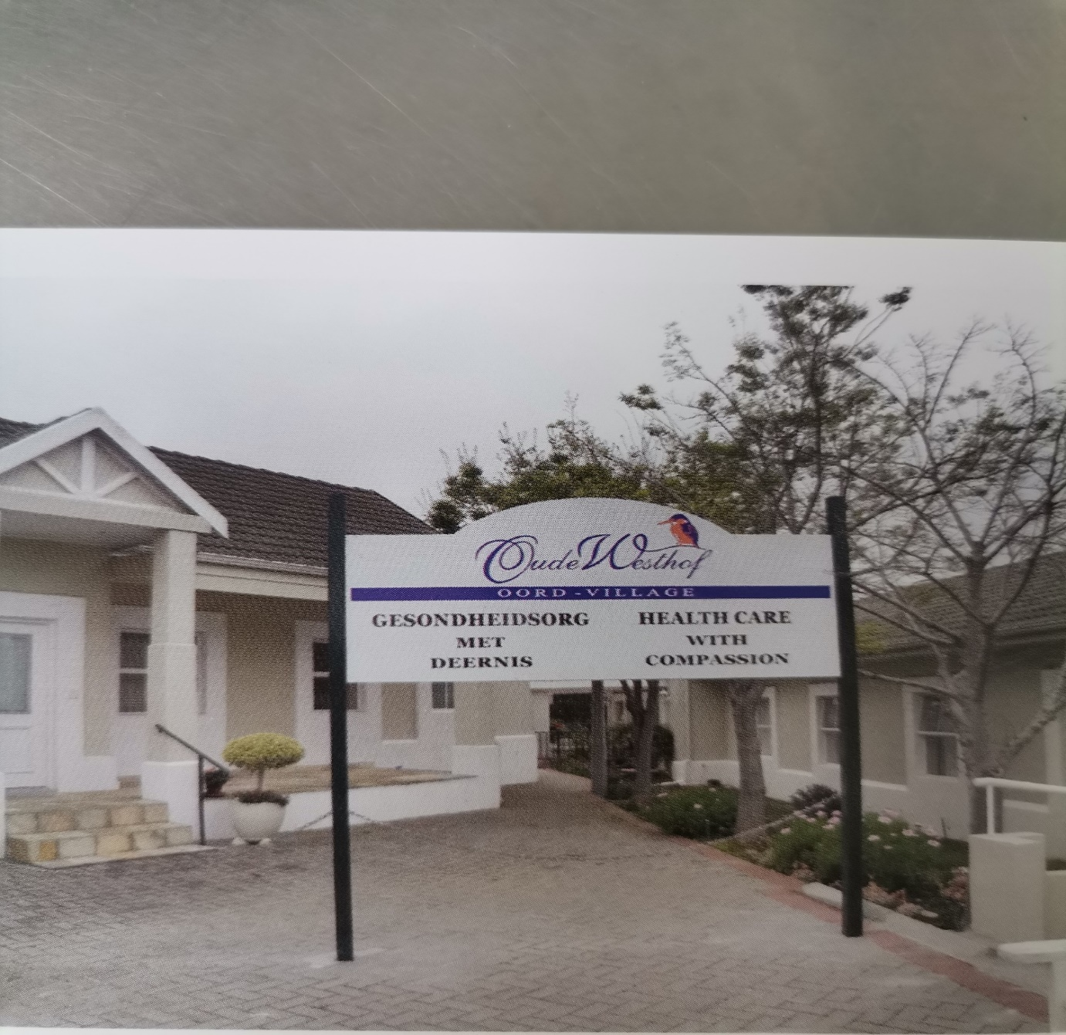

OUDE WESTHOF CARE CENTRE is staffed by highly trained Nursing Staff and Care Workers who provide 24-hour care, including medication management, stimulating activities and daily living assistance.
Services offered include:
- Frail care
- Semi frail care
- Post-operative care
- Short- and long-term management
The Professional Services include:
- 3 balanced meals per day with special attention to special diets
- Tea/coffee x 4 during the day and Milo at night
- Daily laundry
- Hair and nail care on request
- Daily activity and stimulus programs
- Post-operative care
- Short- or long-term patients
- Kitchen (Western Province caterers)
- Secure environment
- 24-hour Security System
- CCTV Camera System
- Electric Fencing
- Fire Management
- Private guest lounge during visiting hours
- Neat and secured lawns and gardens
- Visitor’s parking
- Medicine management (Blister Packs)
- Doctors on Standby from 8:00 to 17:00 x 3
- Ambulance services 24/7
- Post-operative management and care
- Physiotherapy available on booking
- Cleaning Services (Bidvest Prestige Cleaning)
- Social Worker and Occupational Therapist on contract always available
Rooms
- 38-bed facility, 17 rooms with en suite bathrooms, 15 rooms with a toilet and a basin, and 6 rooms with only a basin.
- Hotel Package DSTV available

Residents enjoy these stimulating and happy activities
- In-house get togethers
- Birthday celebrations
- Musical teas or fun meals
Strict Covid-19 protocols in place
We look forward to welcoming you to our Care Centre

OUDE WESTHOF CARE CENTRE
Telephone: 021 9135410
E-Mail: ina@owvhealthcare.co.za
Physical Address: 26 Van Riebeeckshof Road, Van Riebeeckshof
Suburb: BELLVILLE
City: Cape Town
Province: Western Cape

